**Report**

**Dog Selection Project**

Prepared for

Raikhan Murat

Software Design Patterns

By

Principles Group | SE-2116

Aslan Kusainov, Zein Komekbayev, Aiym Yesbossyn,

Olzhas Gabdullin, Aldiyar Batyr

October 28, 2022

Abstract

Dog Selection Project is program made for people who are willing to get a dog, to help them get perfect companion for them. In this report of _ pages are the detailed report with minute details about the work done week by week with explanation to each piece of code.

Agenda

**Why do people really need our project?** 3

**What our project is about?** 3

3rd week: 3

4th week. 4

5th week 5

6th week 7

7th week 10

8th week 18

**GitHub URLs:** 31

# **Why do people really need our project?**

First, pets are the main companions of people, and they need to get their owners. That’s what our project stands for; To find the best dog for person by their preference. Dogs offer us a sense of emotional well-being because of their unconditional affection, which is why they're also terrific companionship and comfort for individuals who live alone. Personal trauma, such as grief, can be helped by owning a dog.

**What our project is about?**

The client, according to the survey, chooses a dog for himself according to the parameters. Next, the program invites him to buy it and gives him a choice. If yes, the program asks for the client's data and then Signs the user by entering data + dog breed. Then the client waits for the required date and is allowed to check whether the dogs are ready for collection.

Job is done from the 3rd week of the trimester

All the patterns covered:

1. Strategy pattern
2. Observer pattern
3. Decorator pattern
4. Factory pattern
5. Singleton pattern
6. State pattern

3rd week:

After division into the commands and explanations of the whole course syllabus we have started to think about the project. Dog selection basically was the best option due to its simplicity and opportunity to alter.

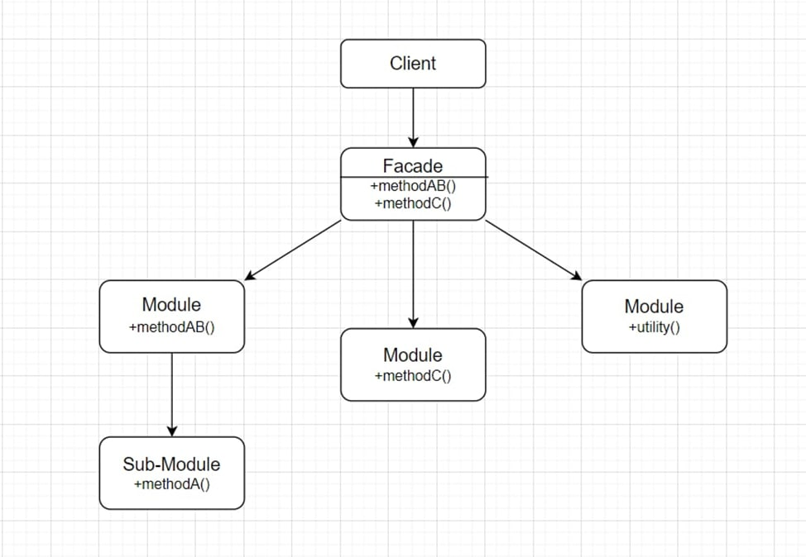

Picture 1. First look

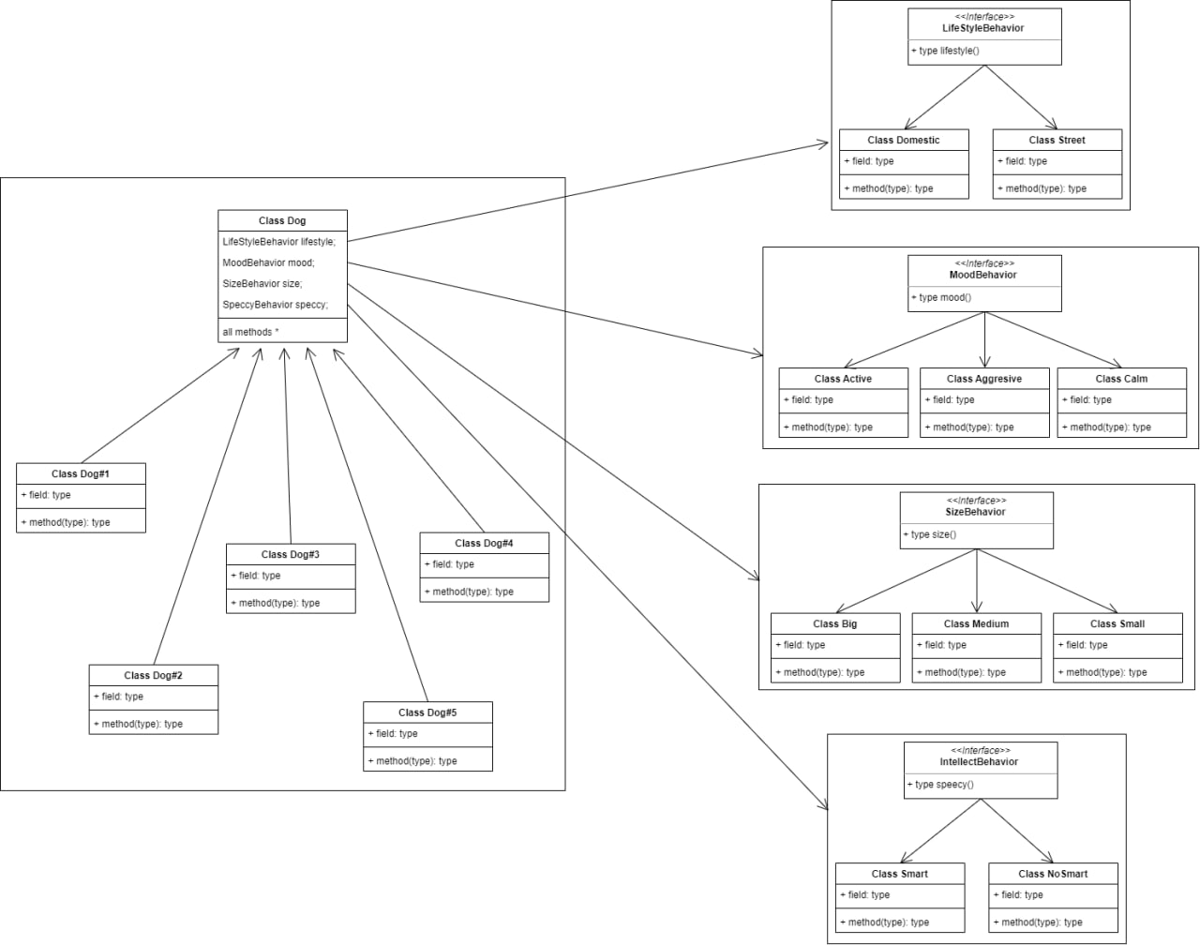

Picture 2. Class dog and interfaces for strategy pattern

When you wish to employ various variations of an algorithm within an object and be able to switch between them during runtime, use the Strategy pattern. The Strategy pattern allows you to change the behavior of an object indirectly at runtime by associating it with multiple sub-objects that can do certain sub-tasks in different ways.

Started to develop strategy pattern first. It was simple because we needed to add interfaces that are standing for methods that dog is functioning. For example, in beta version of project there were interfaces like: barkBehavior, can dog bark or not, and walkBehavior, will dog run or calmly sit. Bur eventually we thought that it would be more logically correct to implement as we did in final version of this pattern.

4th week.

After strategy pattern, we decided to move to the observer pattern where the observer pattern allows the text editor object to notify other service objects of changes in its state. Objects are notified of events that occur to other objects. The list of subscribers is dynamically generated: objects can begin and stop listening to alerts during runtime, depending on the intended behavior of your program. The subscription list is not maintained by the editor class in this implementation. It delegated this task to a specific helper object dedicated to that purpose. That object might be upgraded to function as a centralized event dispatcher, allowing any object to participate as a publisher.

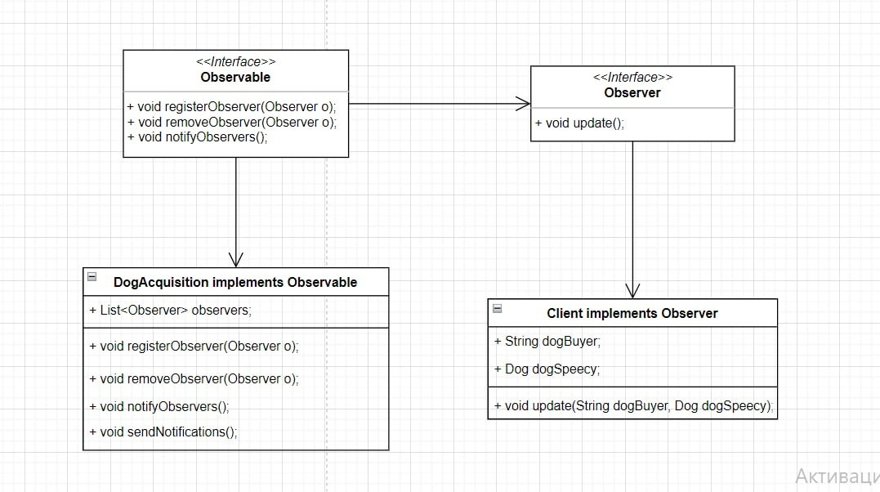

Picture 3. Releasing observer pattern

**In our project**, we added user connection, where user logs in and buys a dog. So afterwards user becomes the observer. There are 10 dog breeds in our project in console program, so by pointing out any of the variant’s user can end up with: There are no such dogs.

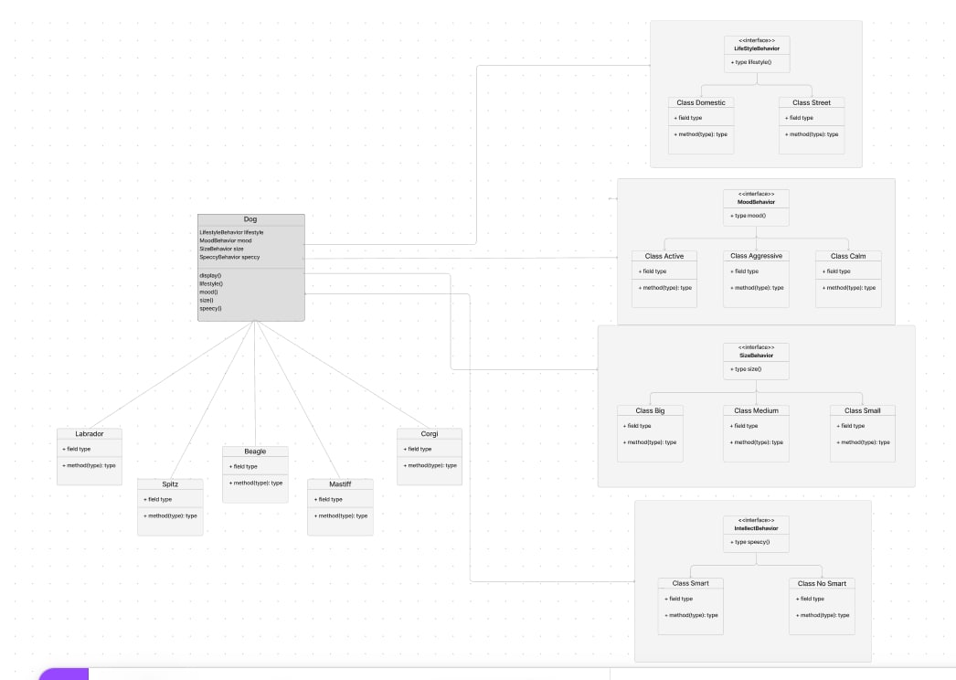

Picture 4. Dog selection with breeds

5th week

The last decorator in the stack is the object with which the client interacts. Because all decorators implement the same interface as the base notifier, the remainder of the client code doesn't care if it works with the "pure" or decorated notifier object.

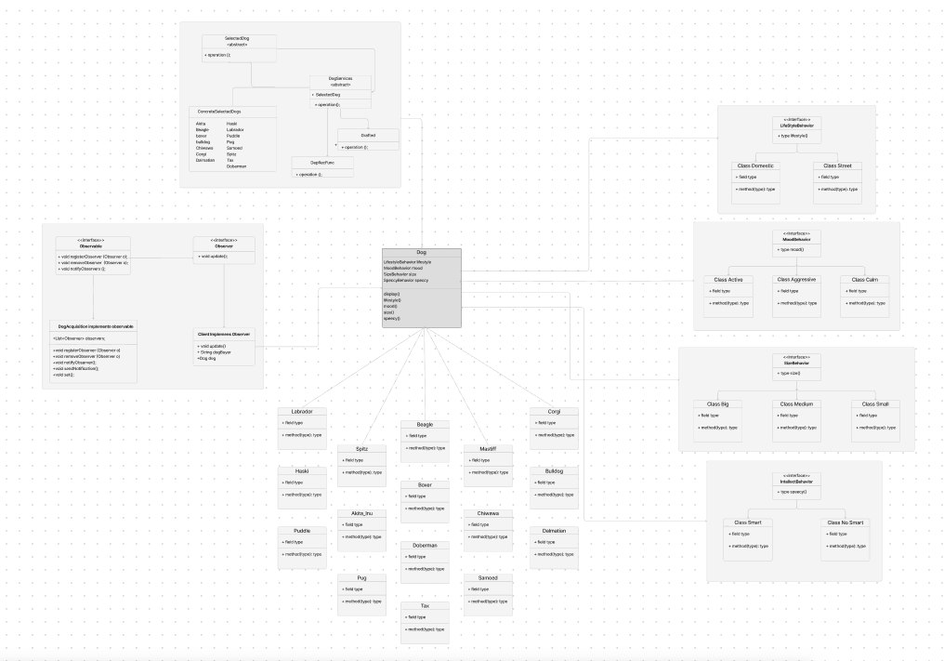

Picture 5. Detailed table of program

Problem started after thinking about adding severe details into the project by making it more complicated. We wanted to add services for dogs beforehand of buying them, like vaccinate or castrate it. So, we went back to the decorator pattern, where we done job user picks several services for dog and it will be added to final price.

PostgreSQL database is added to the project to store all the dog’s information

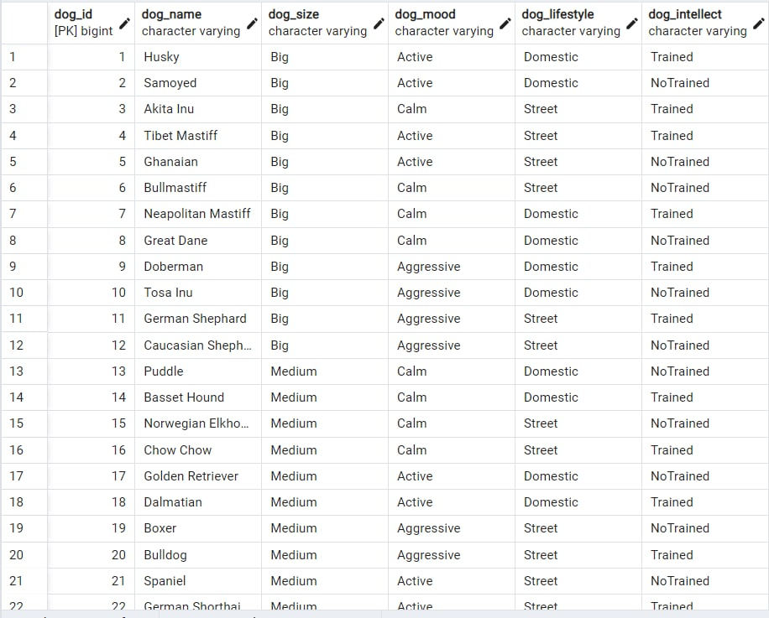

Picture 6. Adding breeds to DB

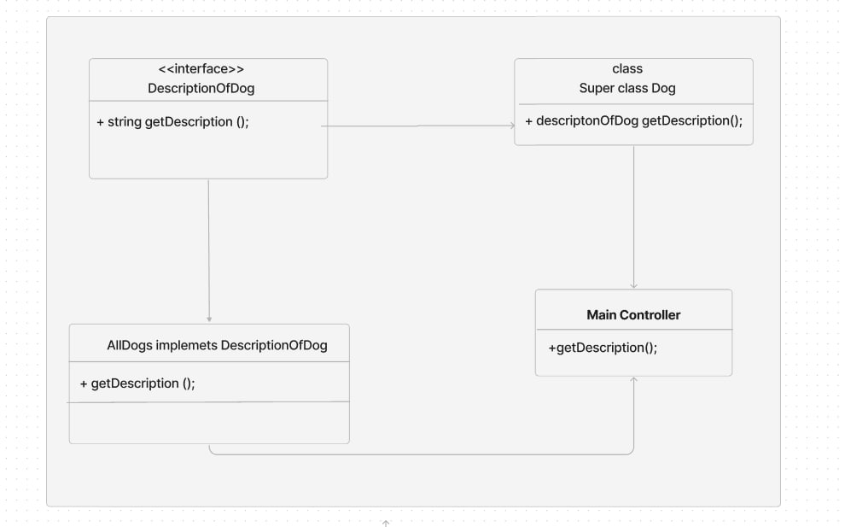

Picture 7. MainController

6th week

When you don't know the specific kinds and dependencies of the objects your code should operate with, use the Factory Method. The Factory Method separates the code that builds the product from the code that utilizes it. As a result, it is easy to extend the product creation code separately from the rest of the code. To add a new product type to the app, for example, simply build a new creator subclass and override the factory function in it.

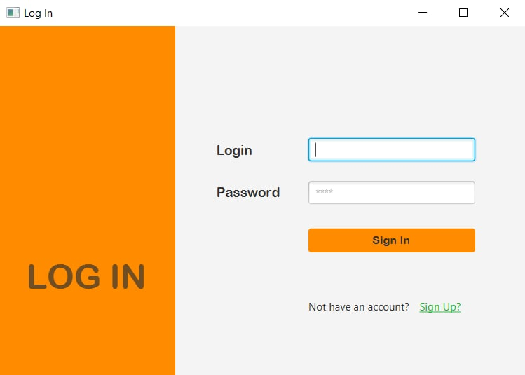

Picture 8. JavaFX login

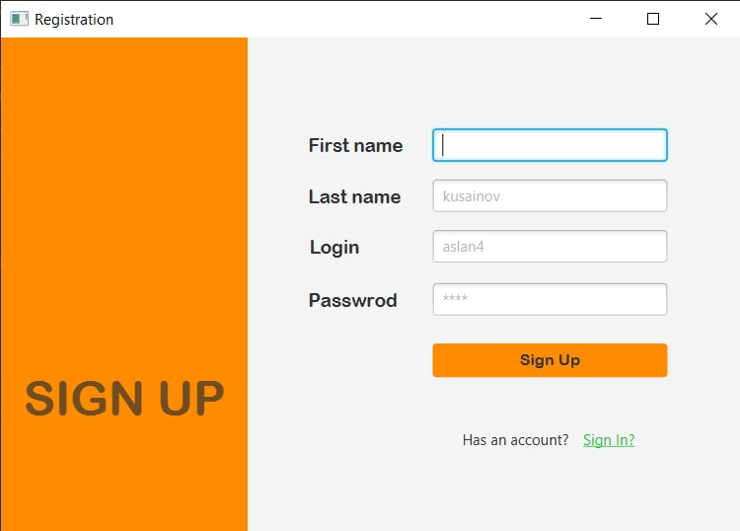

Picture 9. JavaFX signup

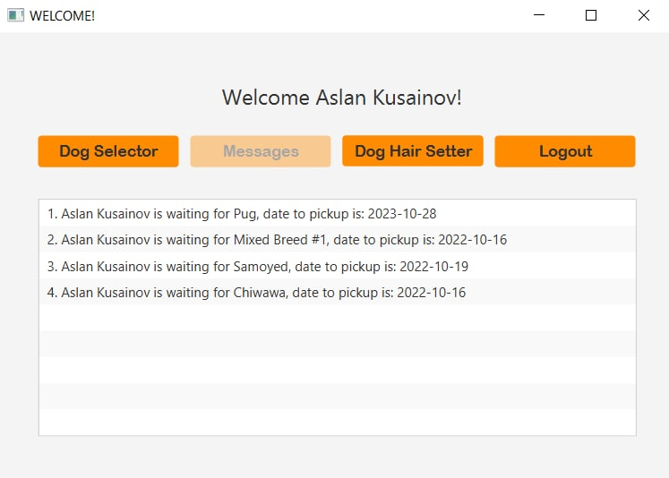

Picture 10. JavaFX messages page

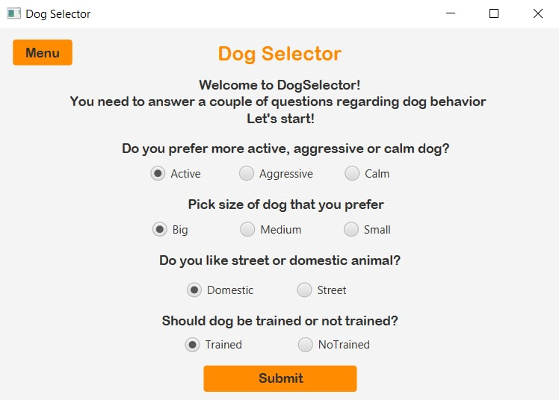

Picture 11. JavaFX beta selector page

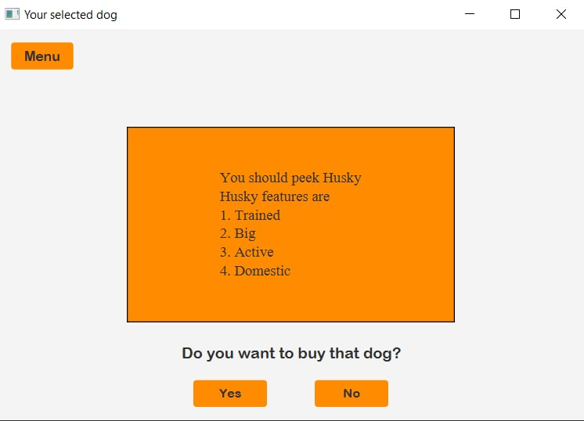

Picture 12. JavaFX beta selection show page

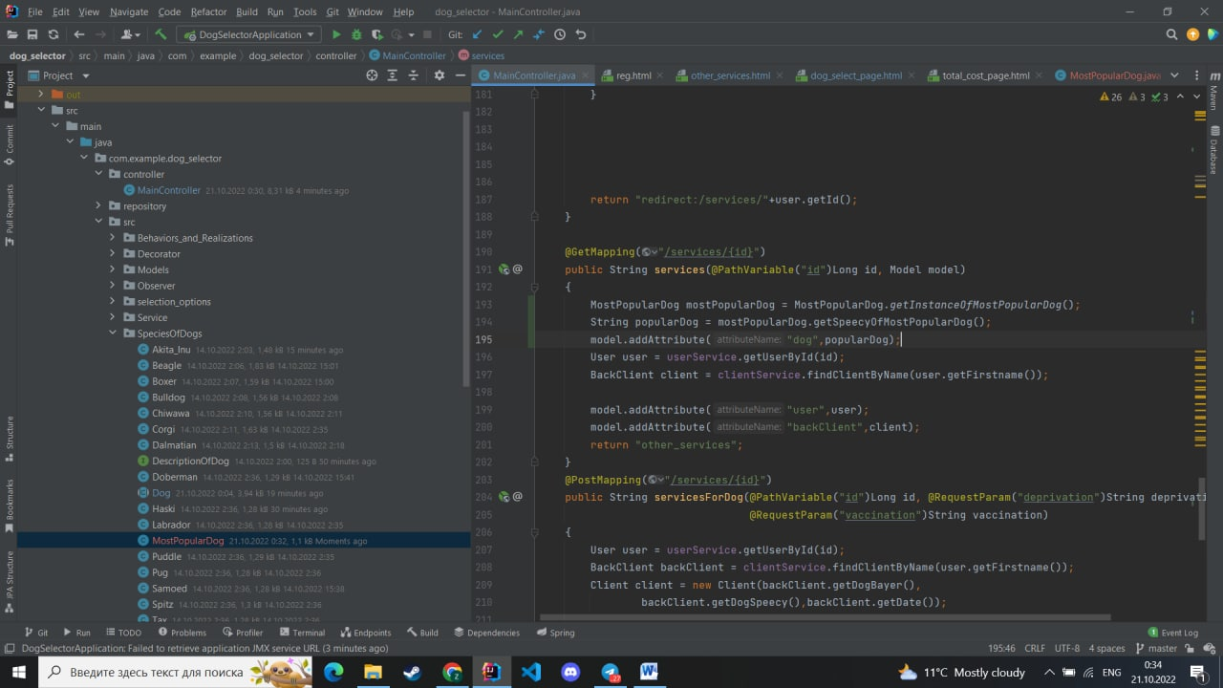

Picture 13. MainController

In our example, factory pattern is shown like

Also, we have calculated all the possible ways to pick a dog and found each one to make combination of behaviours and added better UX/UI with JavaFX

7th week

When a class in your program should have just one instance available to all clients, use the Singleton pattern; for example, a single database object shared by multiple components of the application. Except for the specific creation function, the Singleton design prohibits all other methods of making instances of a class. This function either generates a new object or returns an existing one if one exists.

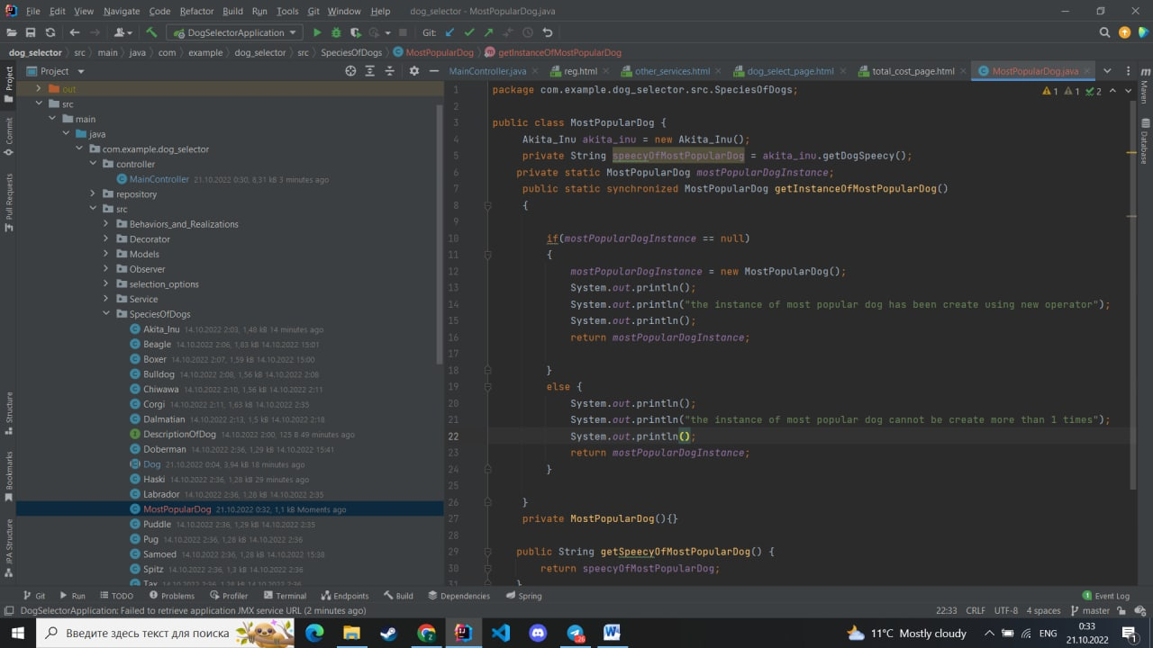

Picture 14. Singleton

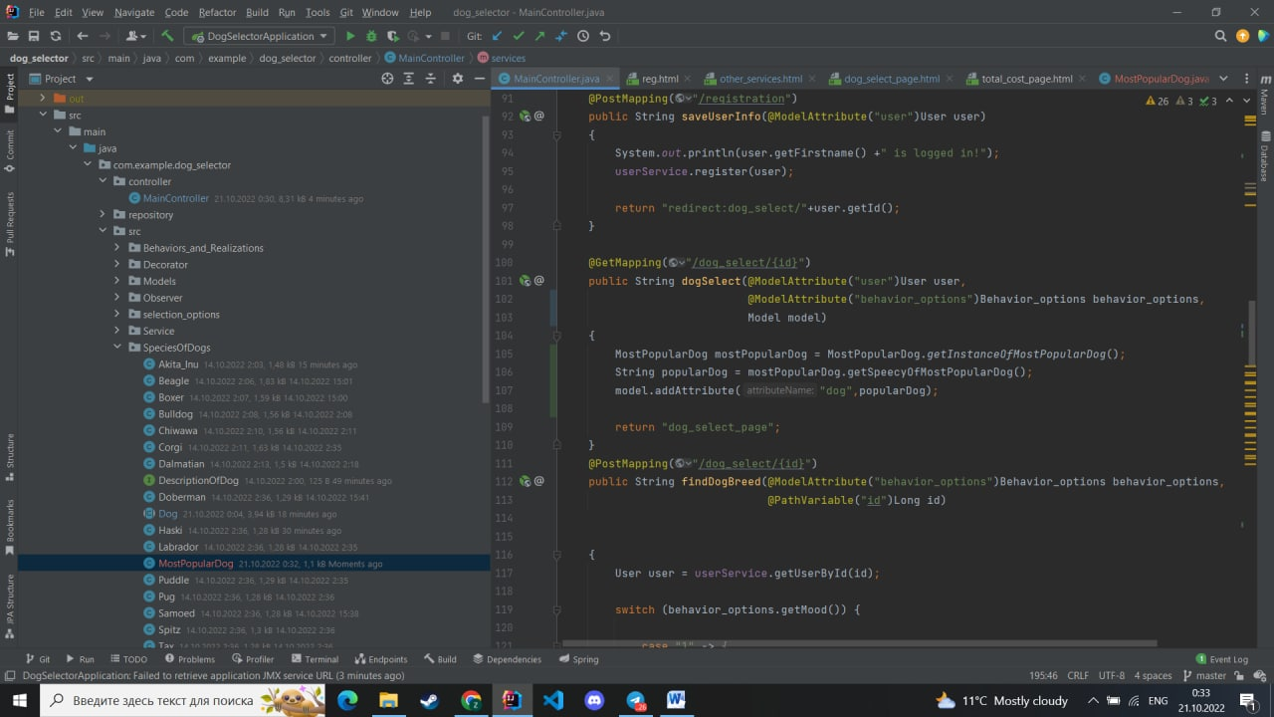

Picture 15. MostPopularDog

Singleton pattern is the locker for the interface. So, if interface is needed, it would be always private. It is breaking SDLC and hardly applicable for any modern projects, but we tried to release it. But we used it once to show the most popular dog among users.

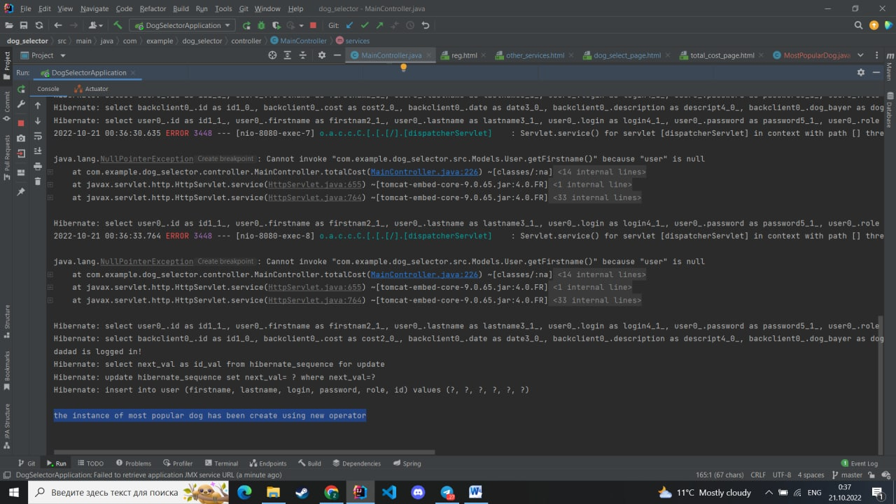

Picture 16. Terminal results

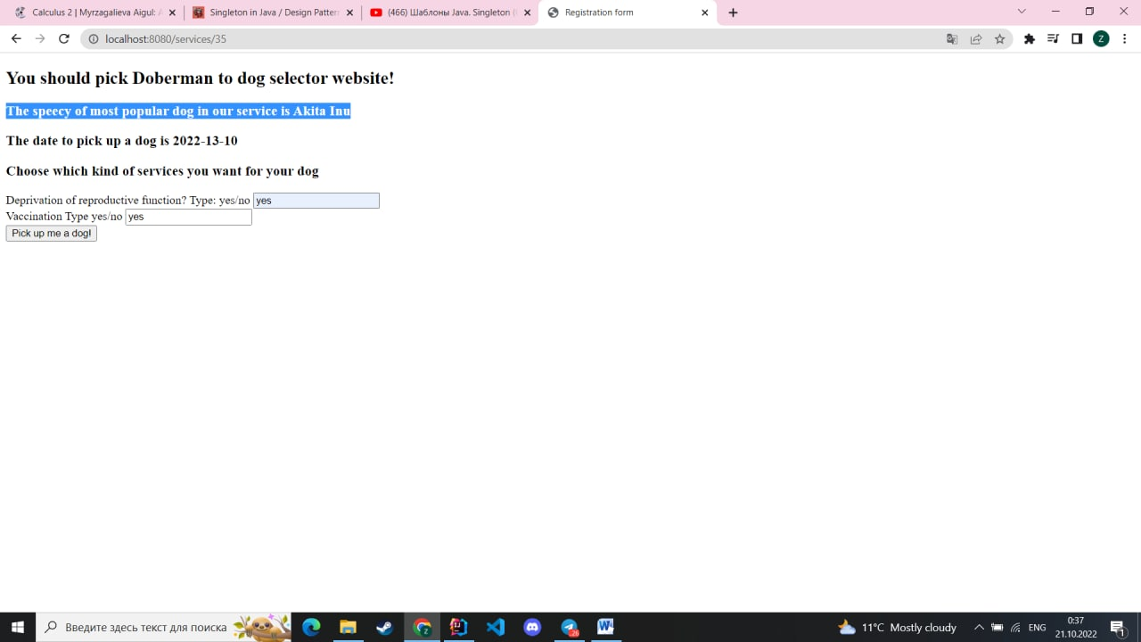

Picture 17. Localhost results.

Also, there has been done a job to improve the UI/UX within a better-looking webpage (which was not working with Spring back then) and reorganized JavaFX.



Picture 18. Logo

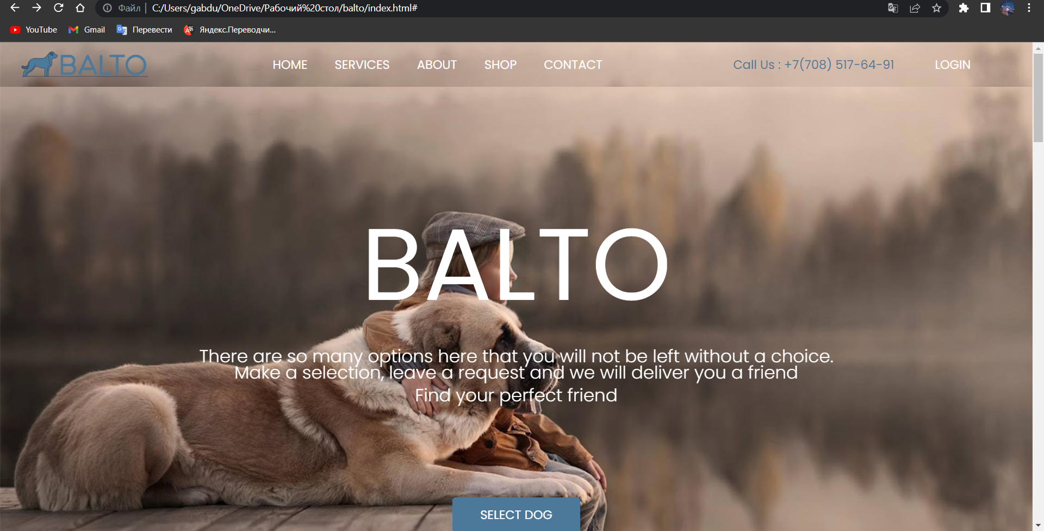

Picture 19. HTML page

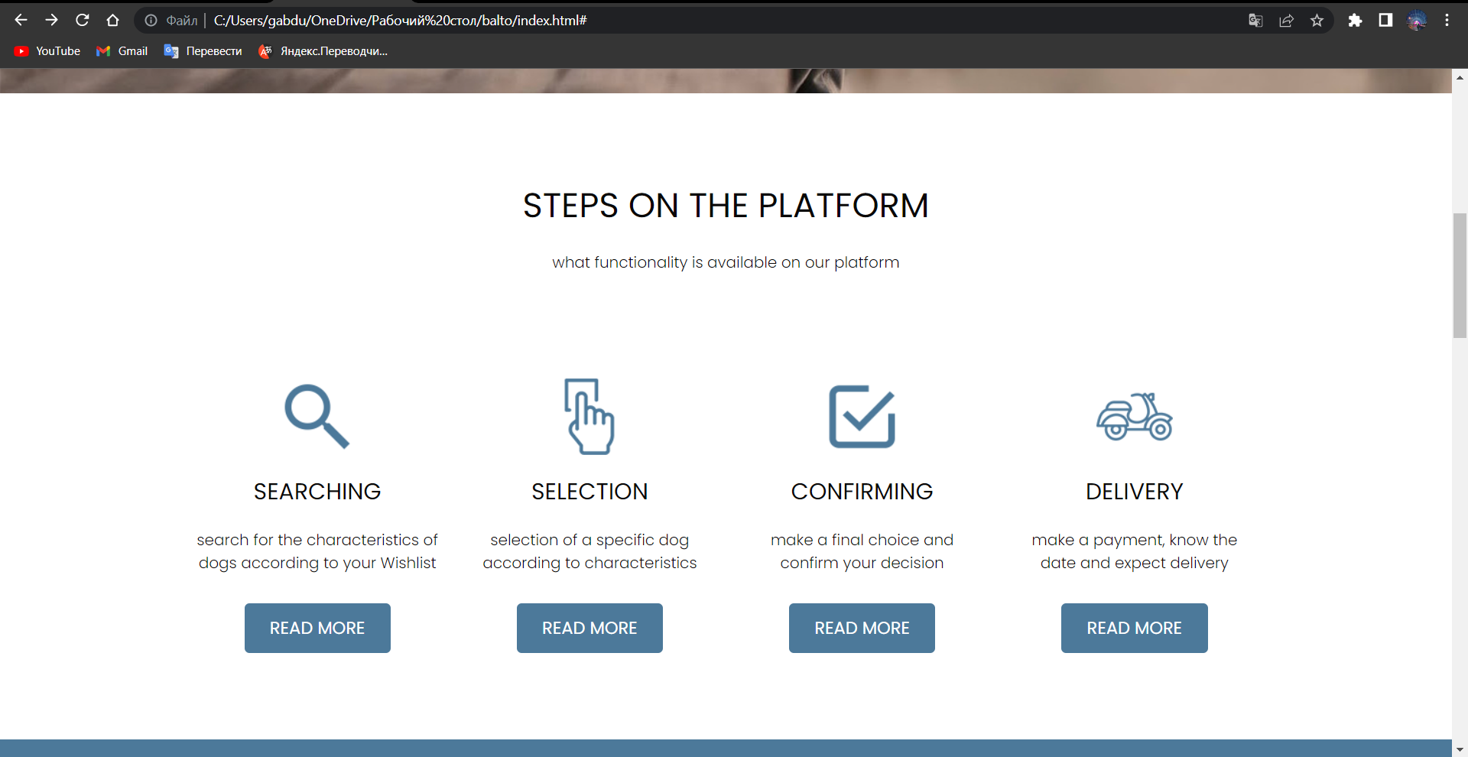

Picture 20. HTML page

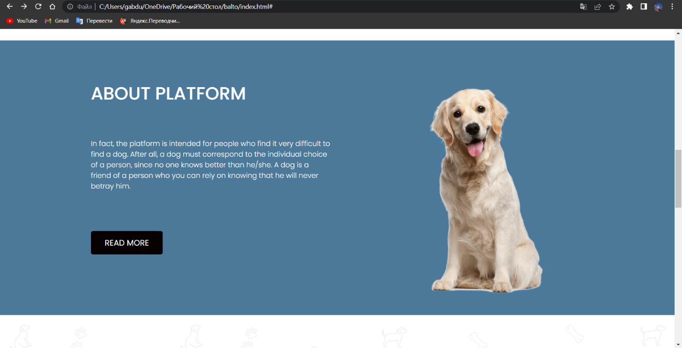

Picture 21. HTML page

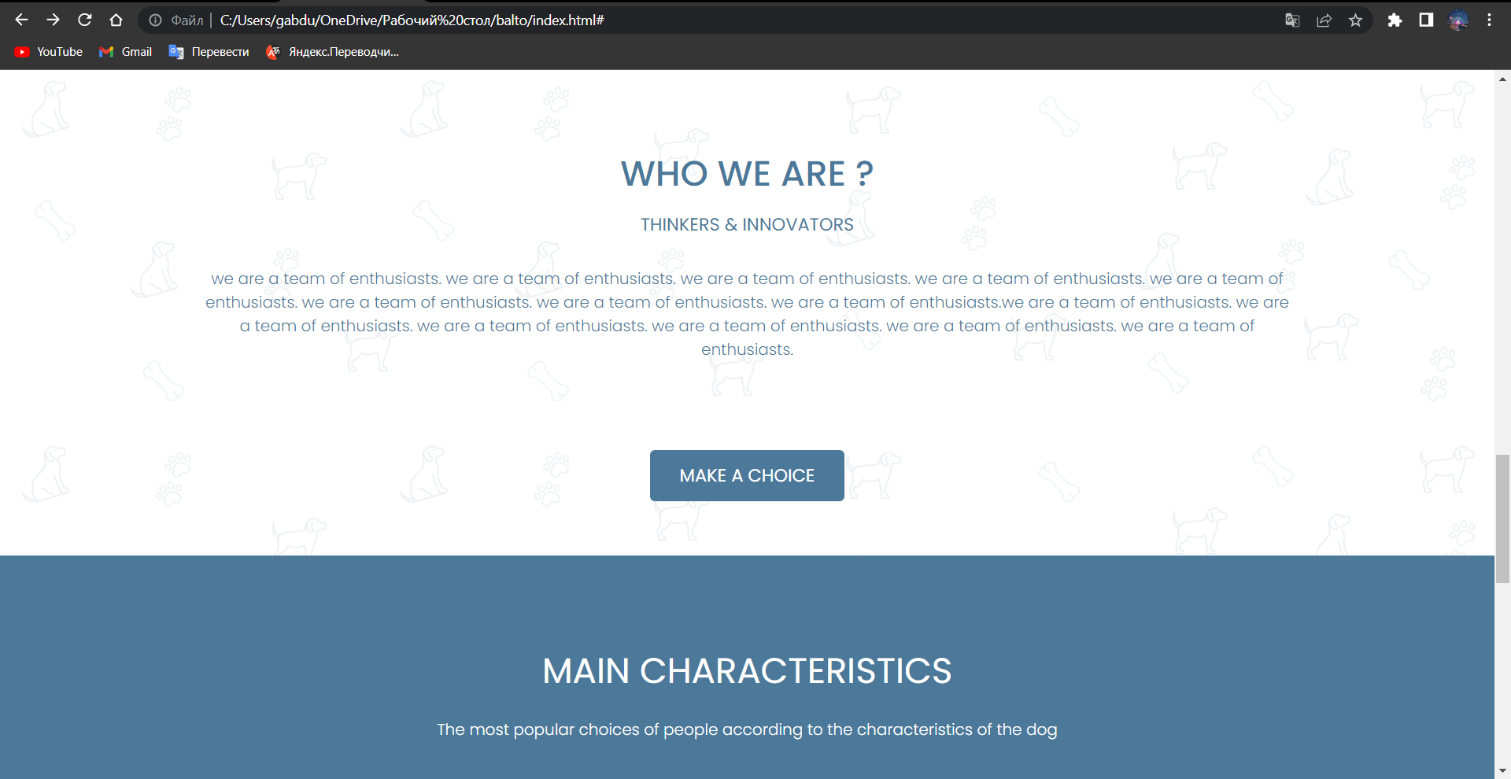

Picture 22. HTML page

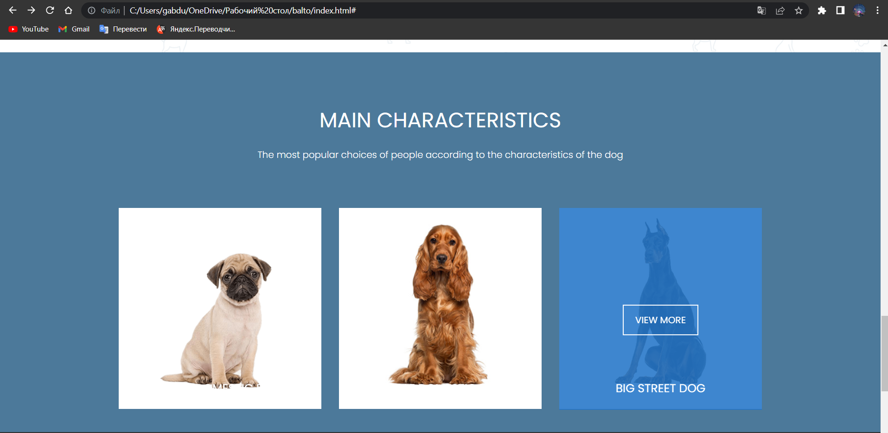

Picture 23. HTML page

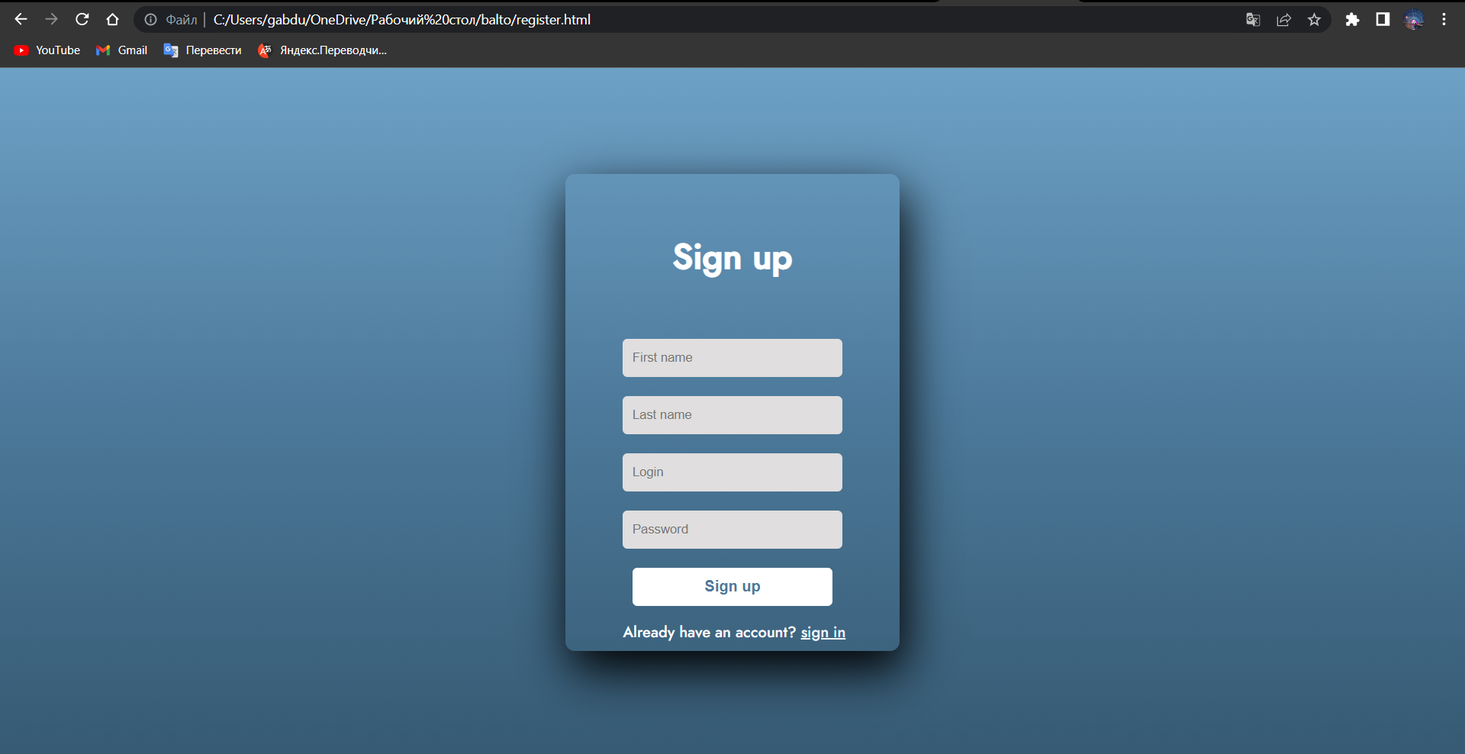

Picture 24. Sign up page

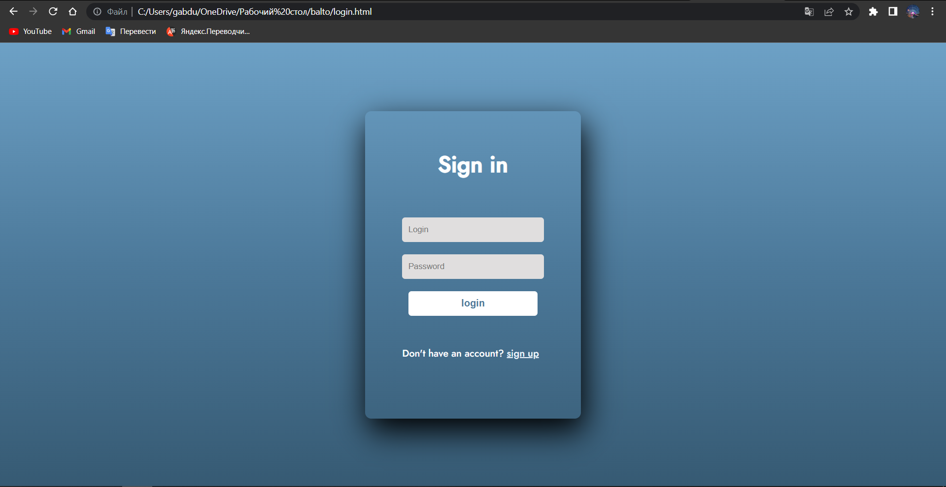

Picture 25. Sign page.

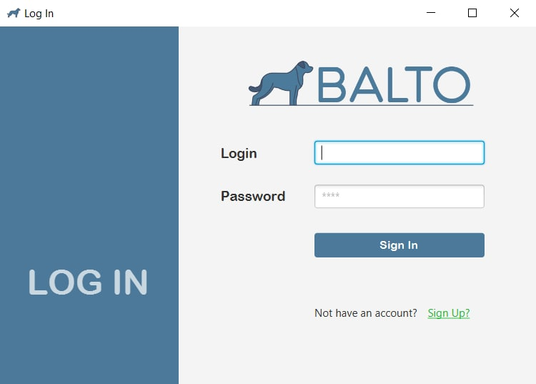

Picture 26. JavaFX Login page

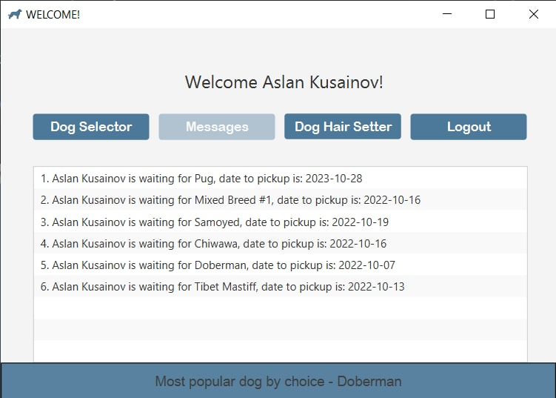

Picture 27. JavaFX Messages

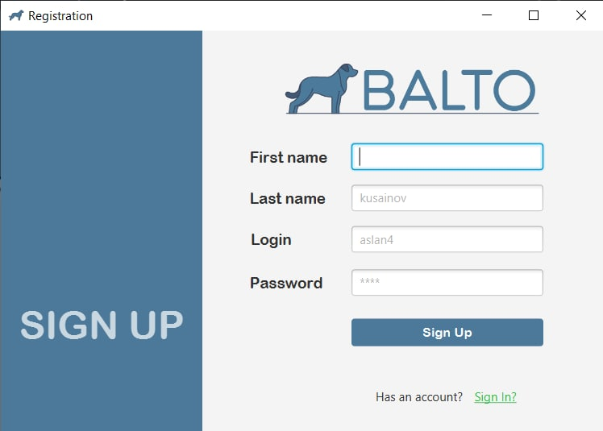

Picture 28. JavaFX Registration

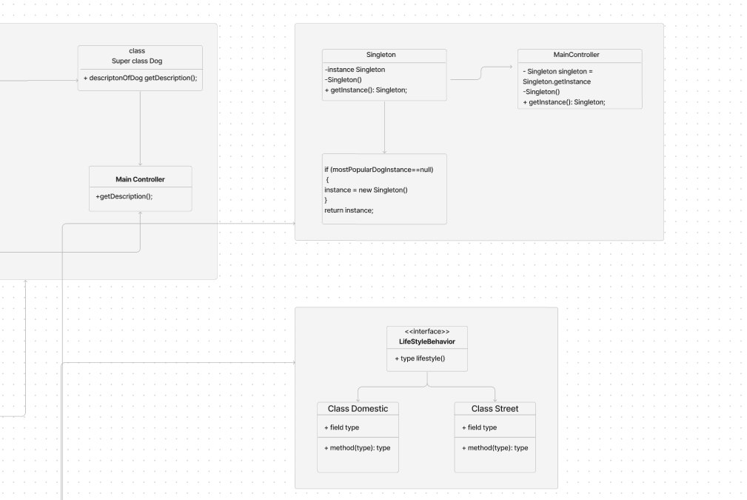

Picture 29. Singleton pattern

8th week

When you have an object that behaves differently based on its current state, use the State pattern; the number of states is large, and the state-specific code changes often. The pattern advises separating all state-specific code into independent classes. Consequently, you may add new states or modify current ones separately, lowering maintenance costs.

Despite the work on new pattern older patterns were developed further.

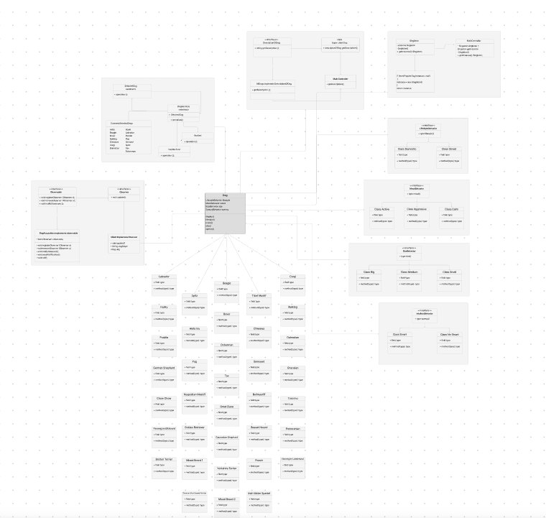

Picture 30. All tables

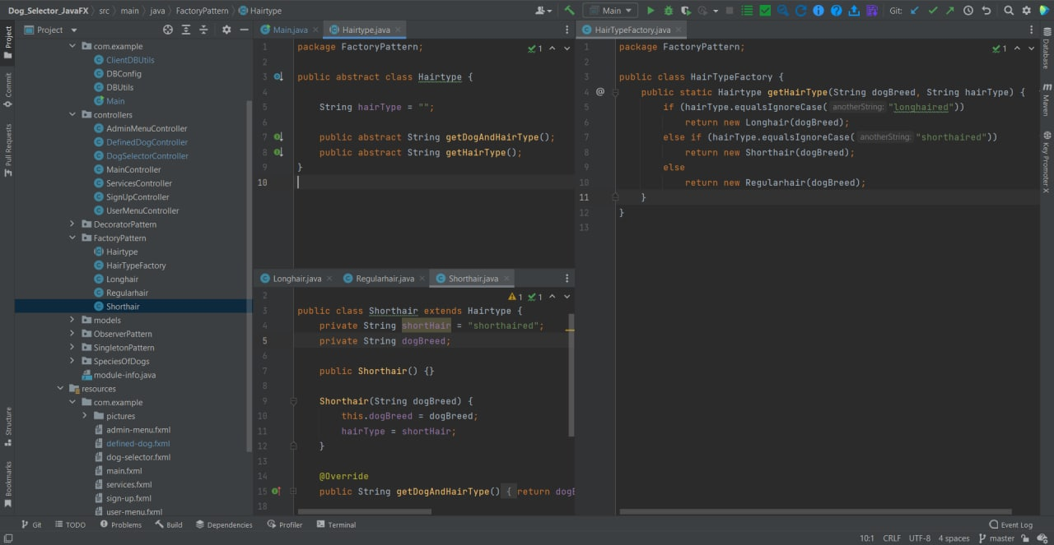

Picture 31. Factory Pattern code

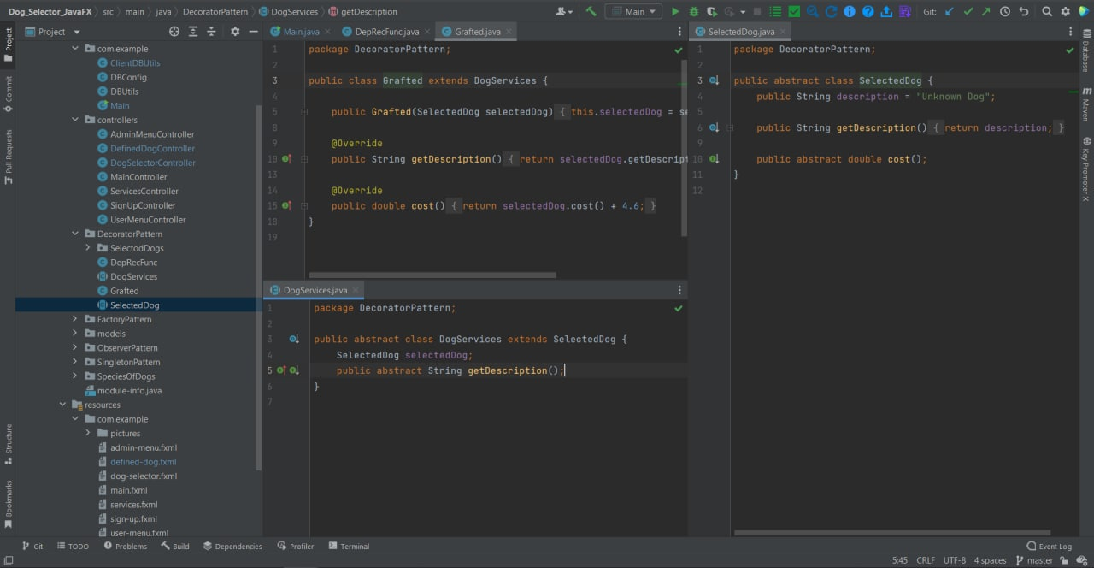

Picture 32.

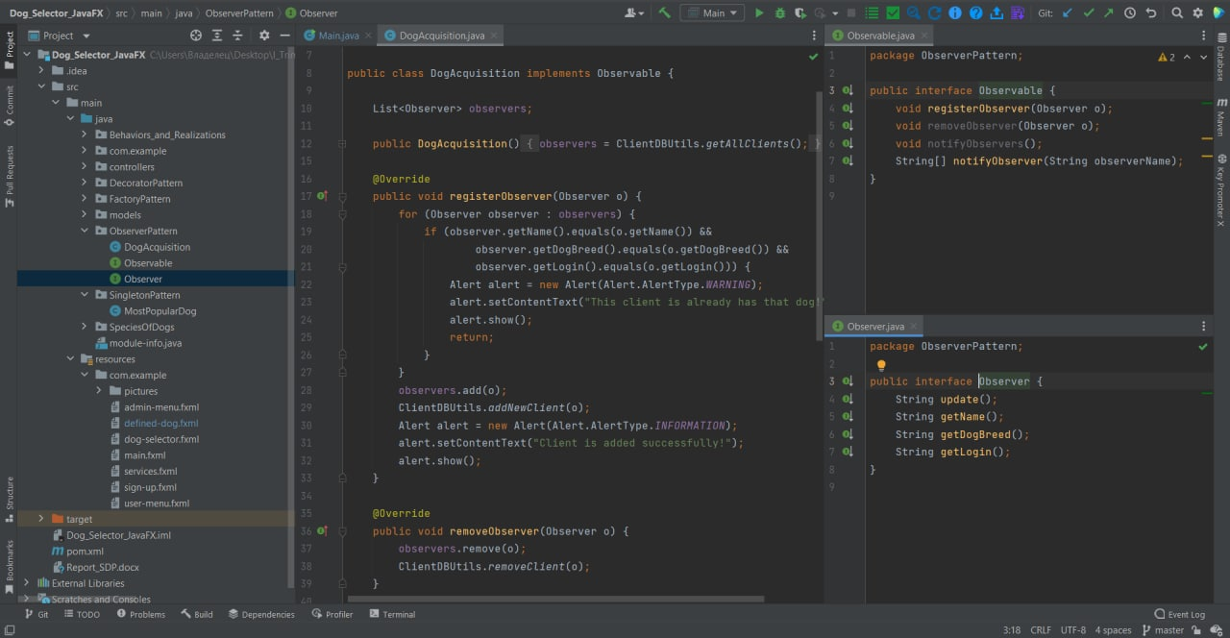

Picture 33.

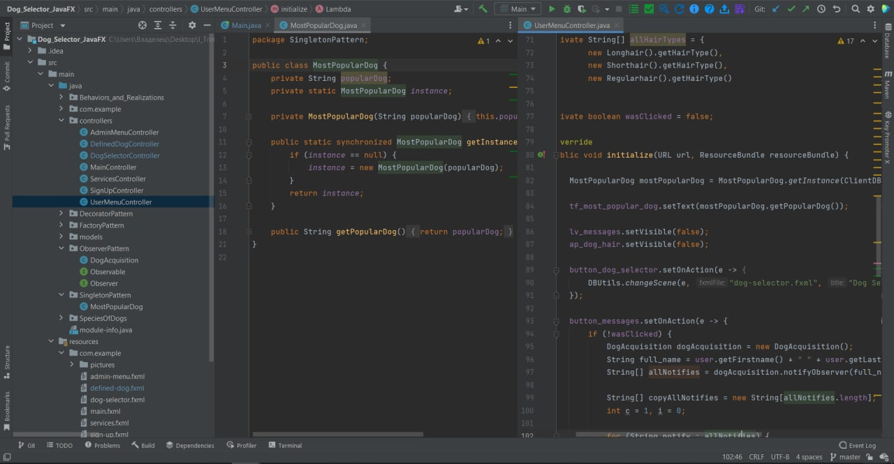

Picture 34.

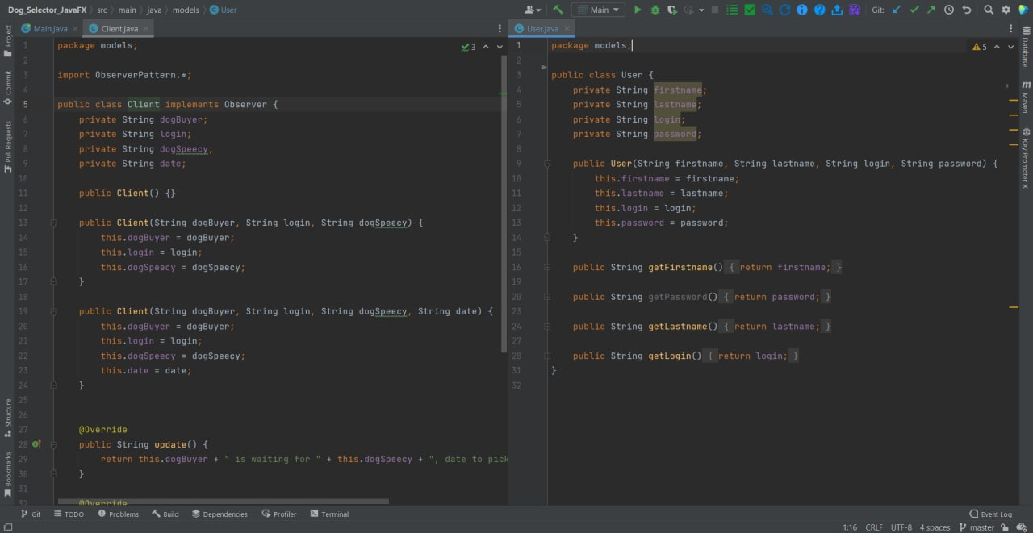

Picture 35.

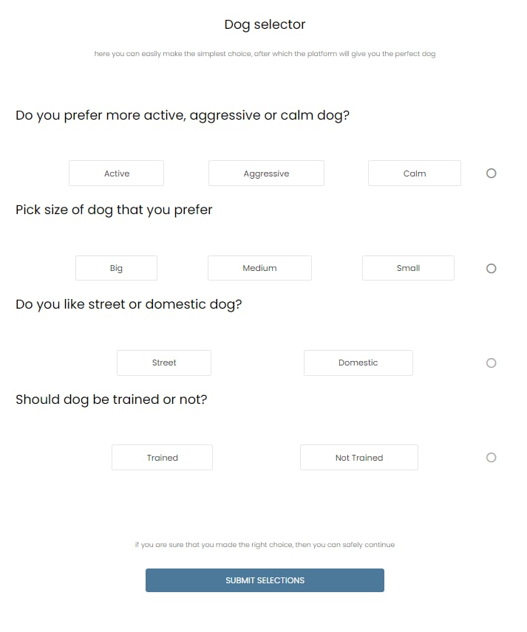

Picture 36. Dog Selector v2 in HTML

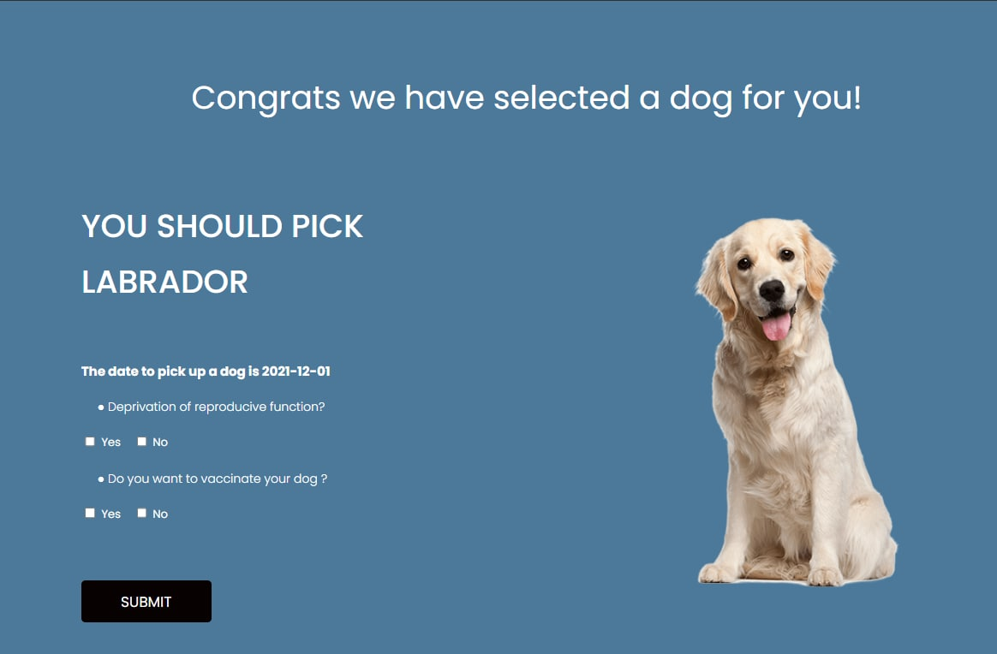

Picture 37. Dog Selection page

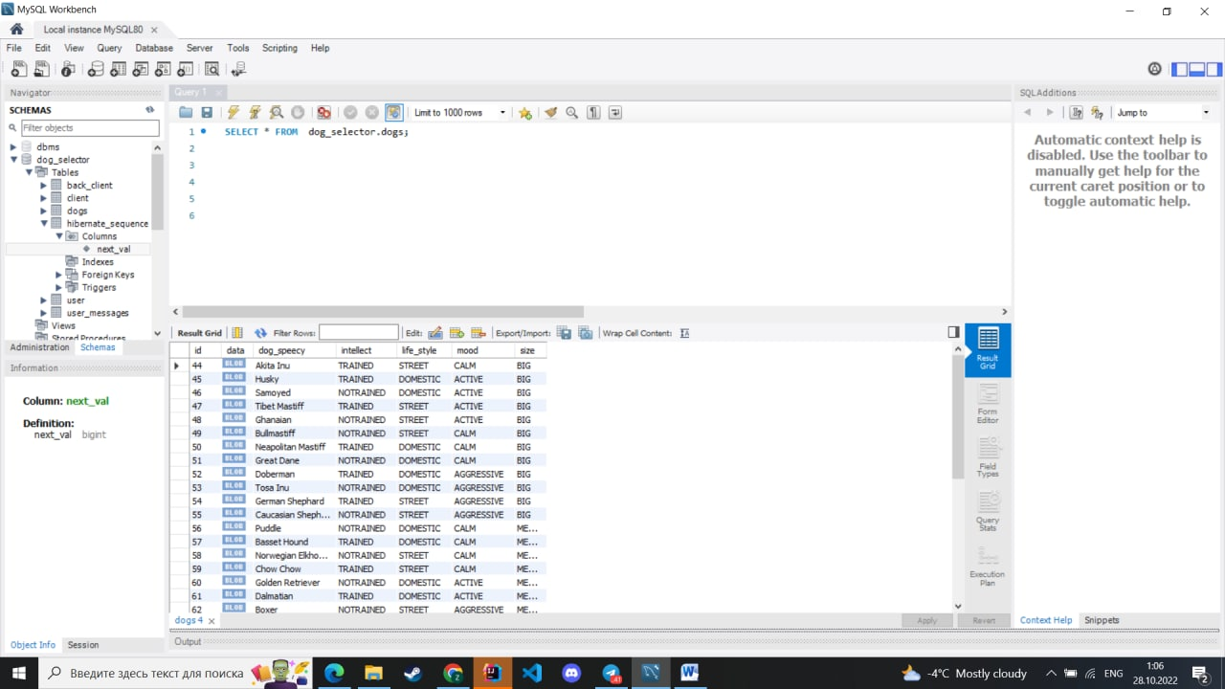

Picture 38. MySQL DB of dog breeds

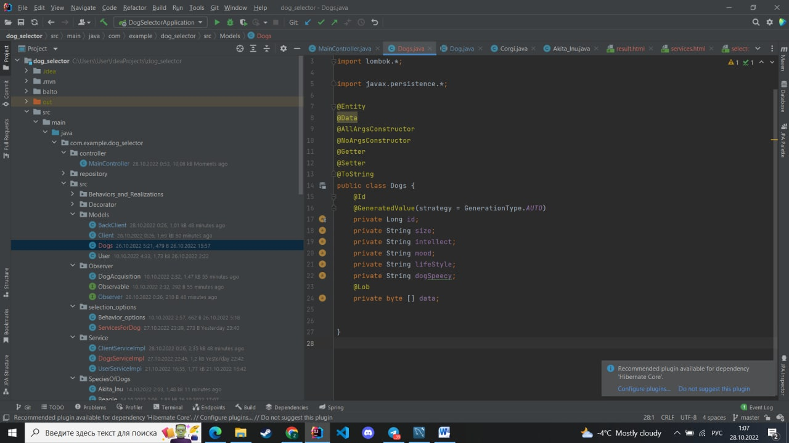

Picture 39. Dog.java page

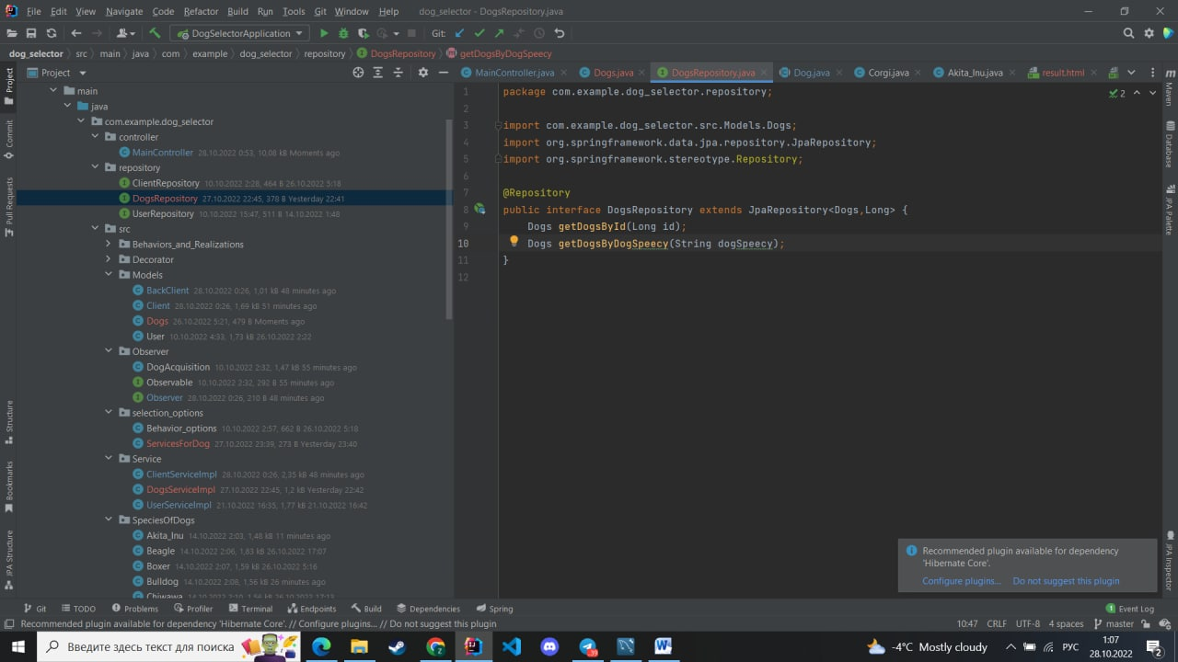

Picture 40. Dog repository page

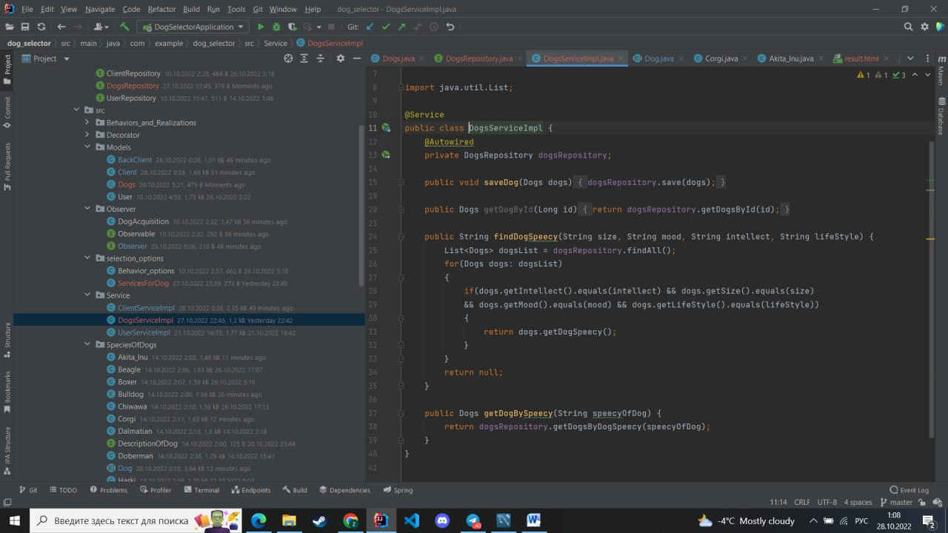

Picture 41. Dog returning code

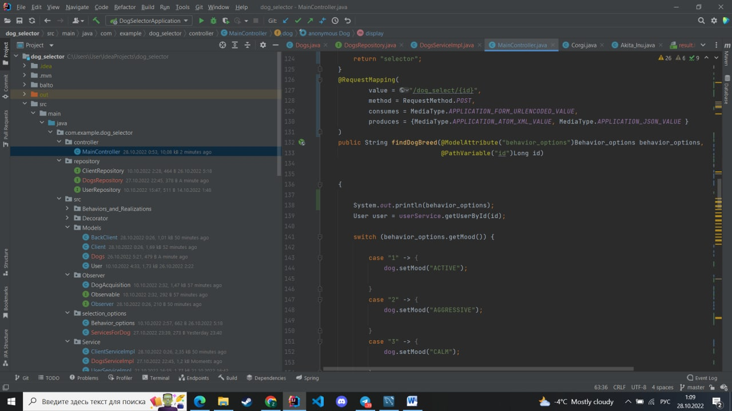

Picture 42. Updated main controller

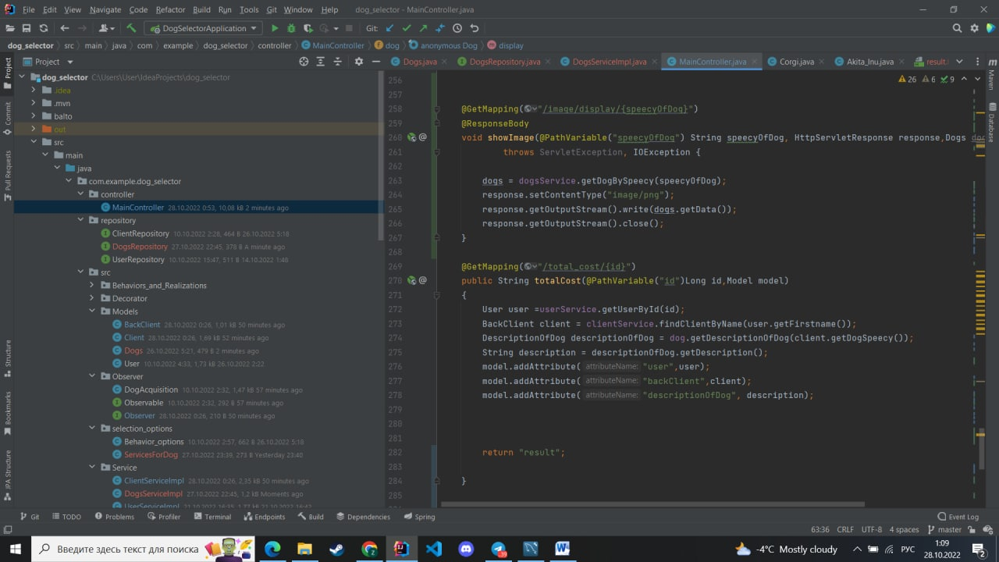

Picture 43. Main controllers continue

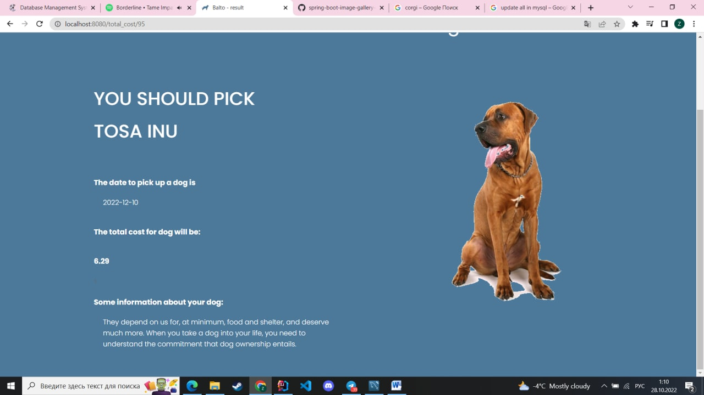

Picture 44. Dog selection page

**In our project,** there are 2 states for dogs, in which dog can have acquisition date or not by default. After acquisition, admin gets informed about dogs state change by message.

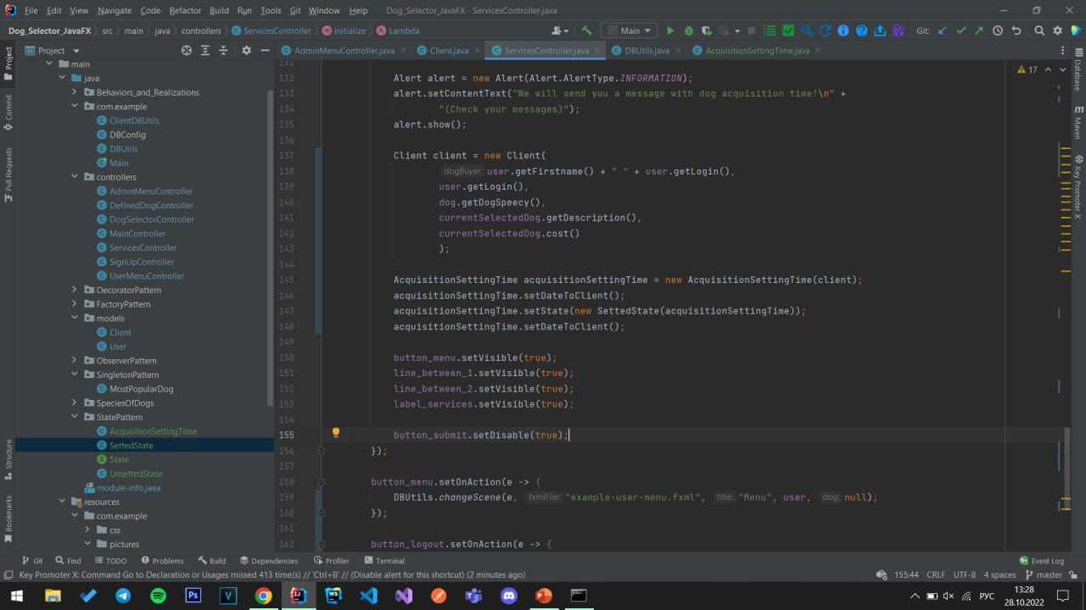Picture 45. Service controller

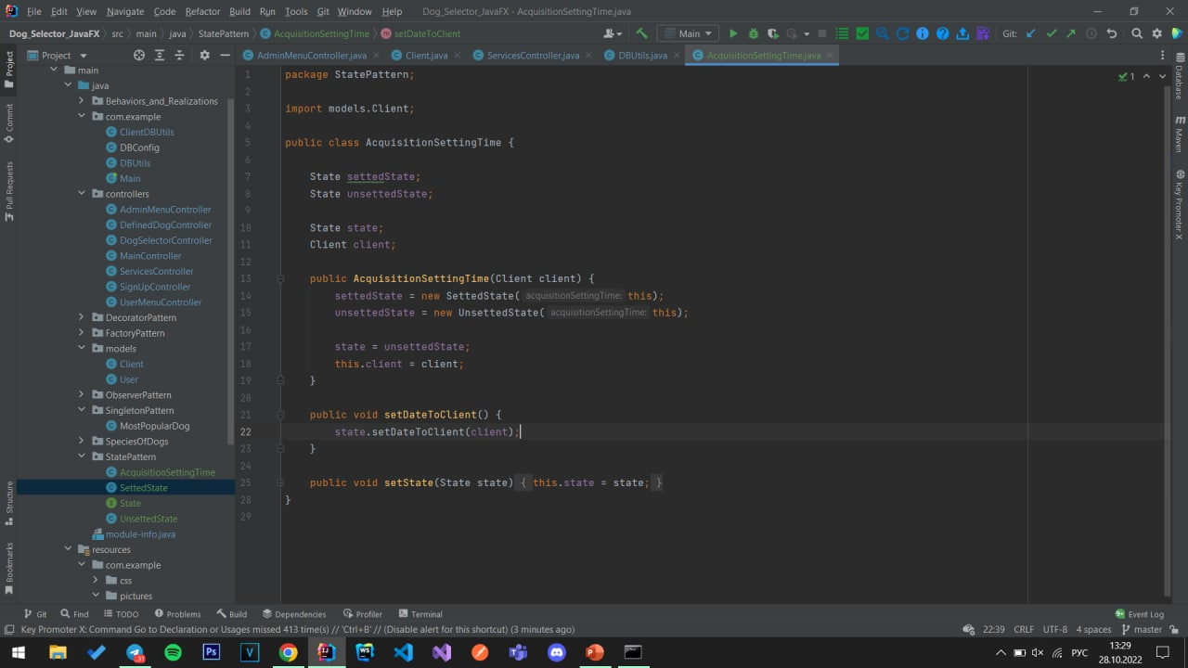Picture 46. State pattern

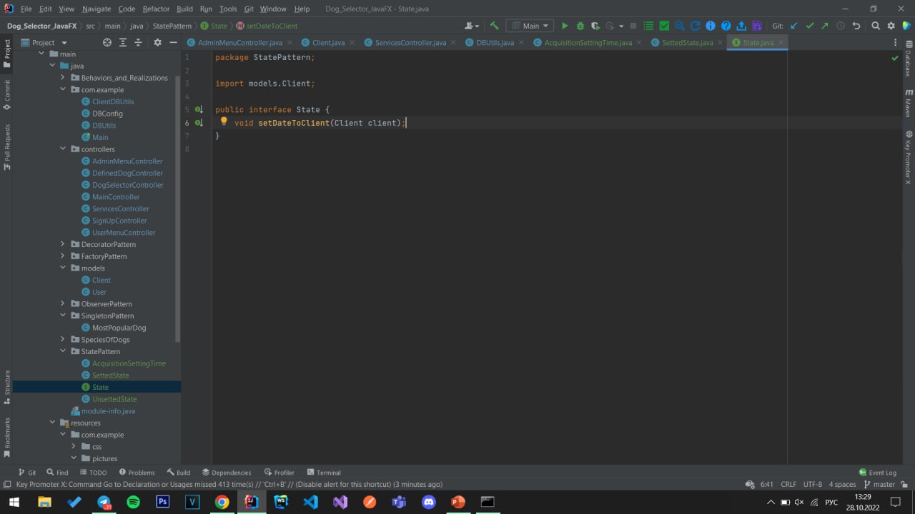Picture 47 State

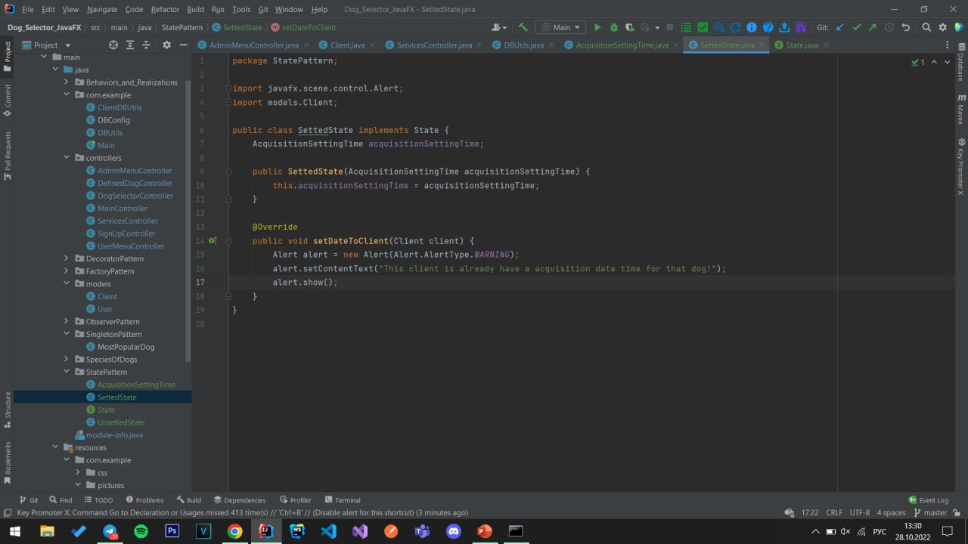

Picture 48. Setting state

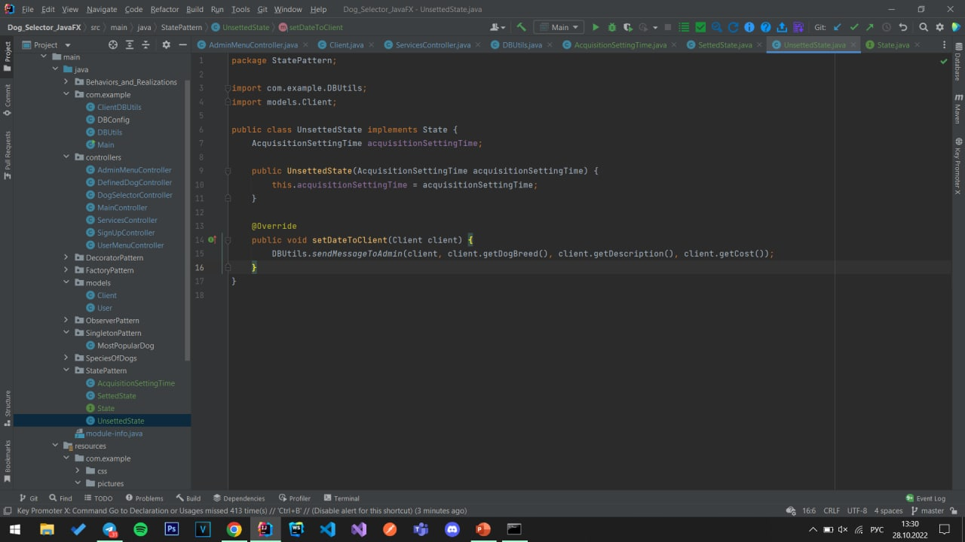

Picture 49. Unsetting state

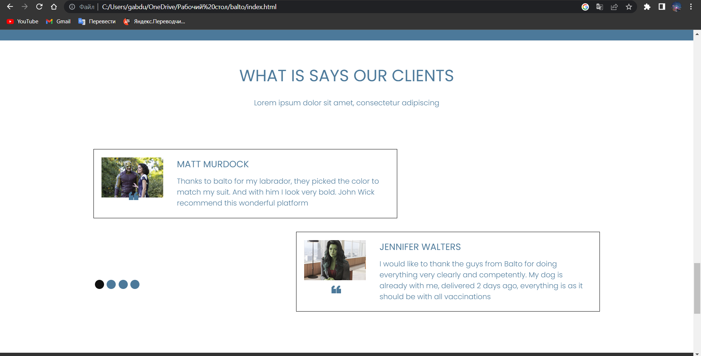

Picture 50. Client review HTML

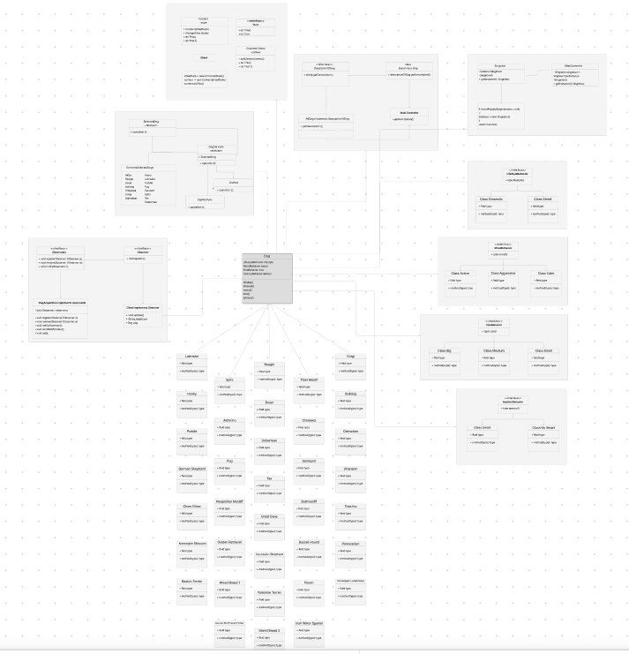

Picture 51. Full table

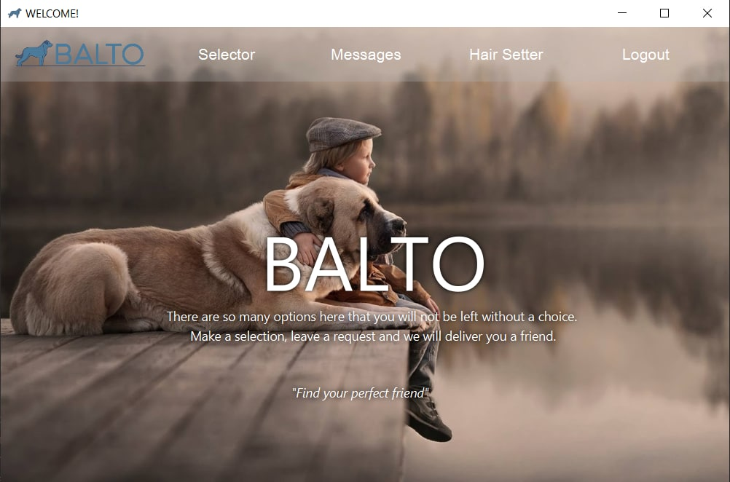

Picture 52. JavaFX Main page

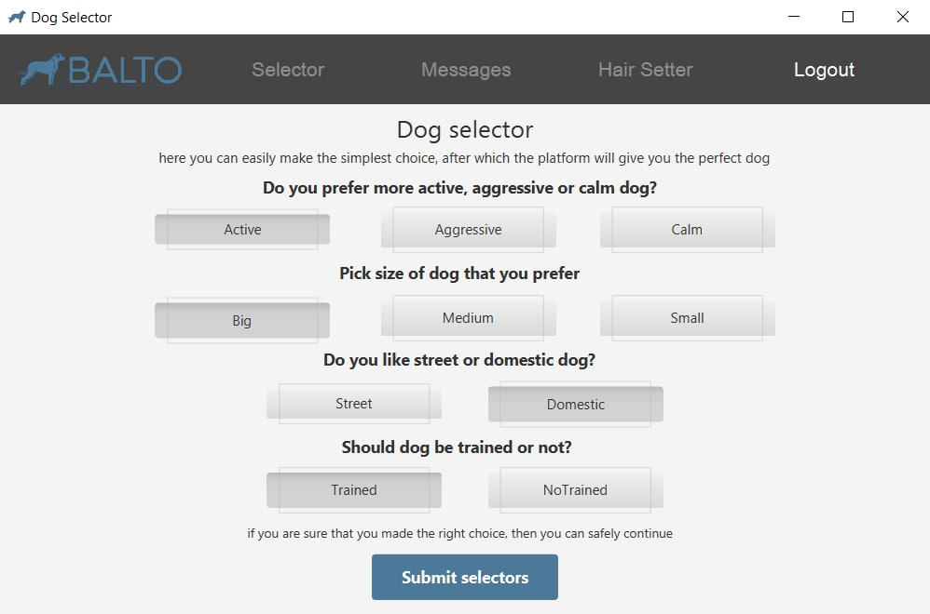

Picture 53. JavaFX Dog selector

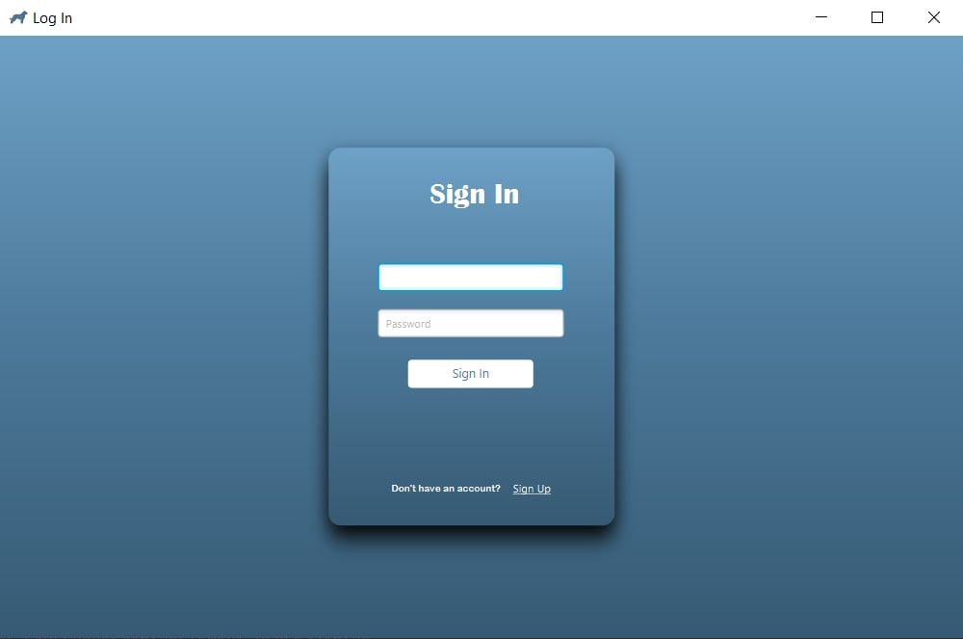

Picture 54. JavaFX Sign in page

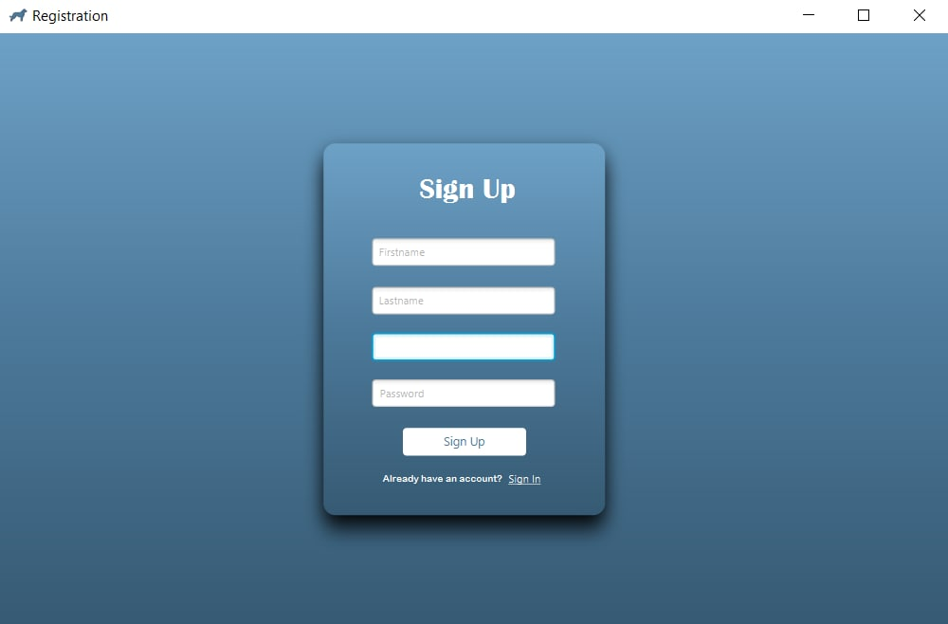

Picture 55. JavaFX Sign up page

# **GitHub URLs:**

<https://github.com/sat0urn/dogselector_javafx>

<https://github.com/Zeiin1/dog_selector>

<https://github.com/sat0urn/dogselector>